**Department of Artificial Intelligence and Machine Learning**

**School of Computer Science & Engineering**

*A Report*

*on*

**Palate Pleasures: A complete “comprehensive” & “responsive” restaurant website**

*carried out as part of the course: AI2132.*

*Submitted by*

***Aviral Sanjay Gupta***

***Registration No.: 219310322***

***AIML-IV***

*in partial fulfilment for the award of the degree*

*of*

**BACHELOR OF TECHNOLOGY**

In

**Computer Science and Engineering (AIML)**

**Manipal University Jaipur-303007.**

***May, 2023.***

**Acknowledgement**

This project would not have completed without the help, support, comments, advice, cooperation and coordination of various people. However, it is impossible to thank everyone individually; I am hereby making a humble effort to thank some of them.

I acknowledge and express my deepest sense of gratitude of my internal supervisor Dr. Deepti Sharmafor her constant support, guidance, and continuous engagement. I highly appreciate his technical comments, suggestions, and criticism during the progress of this project “Palate Pleasures”.

I owe my profound gratitude to Mr. Sandeep Chaurasia, Head, Department of CSE AI-ML, for his valuable guidance and facilitating me during my work. I am also very grateful to all the faculty members and staff for their precious support and cooperation during the development of this project.

Finally, I extend my heartfelt appreciation to my classmates for their help and encouragement.

**Thank You.**

**Web Technology Mini-Project**

**Palate Pleasures**

A complete “Comprehensive” & “Responsive” Restaurant Website

**Introduction:** Welcome to Palate Pleasures, a website for our restaurant that offers a variety of delicious dishes to satisfy your cravings. Our website is designed to enhance your dining experience and provide you with easy access to all the information you need. Here is a brief overview of the different modules of our website:

* **Home Page:** Our home page is designed to give you a warm welcome and showcase the best of what Palate Pleasures has to offer. It is designed to be visually appealing and easy to navigate, with a clean and modern layout that highlights the key features of our restaurant.

Overall, our home page is designed to give guests a glimpse into what they can expect from Palate Pleasures, from our delectable menu offerings to our commitment to providing an exceptional dining experience.

* **About Page:** Our about page is where guests can learn more about the history, vision, and values of Palate Pleasures.

At Palate Pleasures, we are passionate about using fresh, high-quality ingredients to create dishes that are both delicious and nutritious. Our about page highlights this commitment to quality, as well as our dedication to using sustainable and eco-friendly practices wherever possible.

Overall, our about page is a great way for guests to get to know more about Palate Pleasures beyond just our menu offerings. It allows us to showcase what we stand for, what sets us apart from other restaurants, and what our guests can expect when they dine with us.

* **Menu Page:** Our menu page is where guests can browse our extensive range of dishes, which are crafted by our experienced chefs using only the freshest and highest quality ingredients.

Our menu page is designed to be easy to navigate, with sections for starters, entrees, sides, desserts, and beverages. We also include icons to denote vegan, vegetarian, and gluten-free options, making it easy for guests to quickly identify dishes that fit their dietary preferences.

Overall, our menu page is a great way for guests to get a sense of the quality and variety of our menu offerings. We take great pride in our food and beverage menus, and we're confident that there's something on our menu that will delight every palate.

* **Contact Page:** Our contact page is where guests can find all the information, they need to get in touch with us, whether they have questions about our menu, want to book a reservation, or simply want to give us feedback about their dining experience.

Overall, our contact page is an important part of our website that allows guests to easily connect with us and get the information they need to plan their visit to Palate Pleasures.

**Booking Page:** Our booking page is where guests can make reservations to dine at Palate Pleasures. We believe that booking a table should be quick and easy, which is why we've designed our booking page to be simple and user-friendly.

Overall, our booking page is an important part of our website that allows guests to easily and efficiently make reservations to dine at Palate Pleasures. We strive to make the booking process as seamless as possible, so guests can focus on enjoying their dining experience with us.

**Software Specifications:** HTML, CSS & JAVASCRIPT.

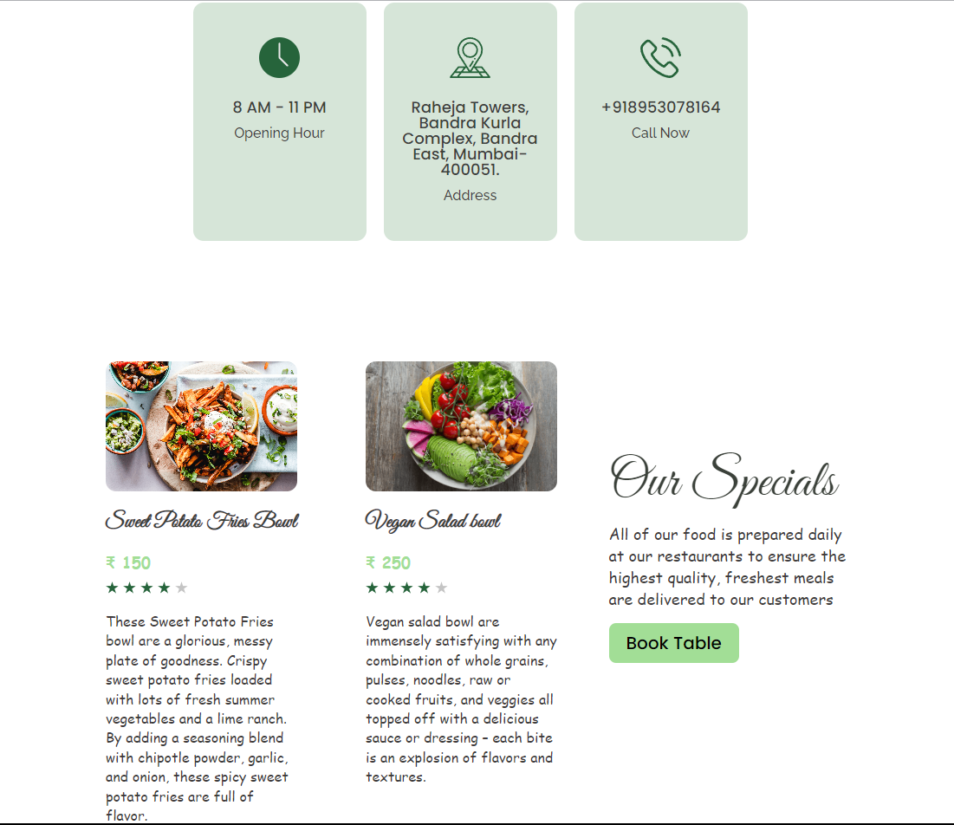**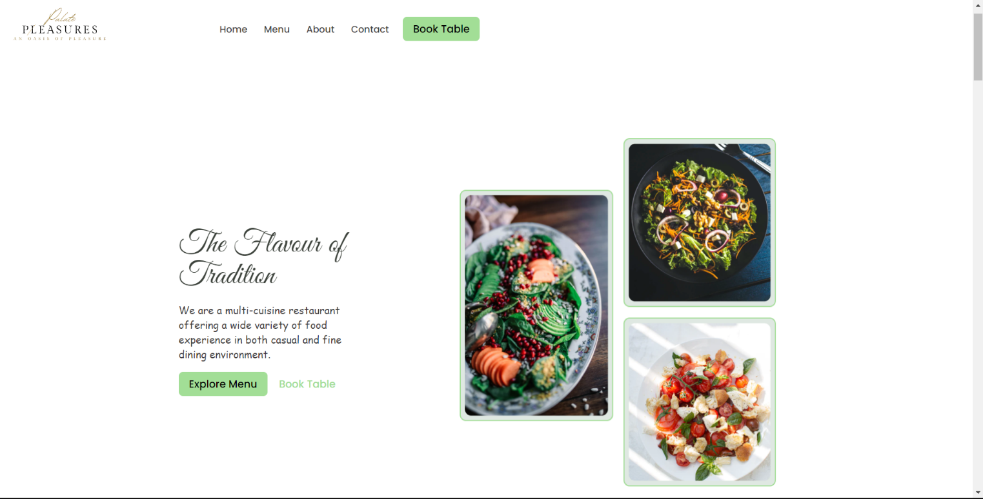Picture Gallery:**

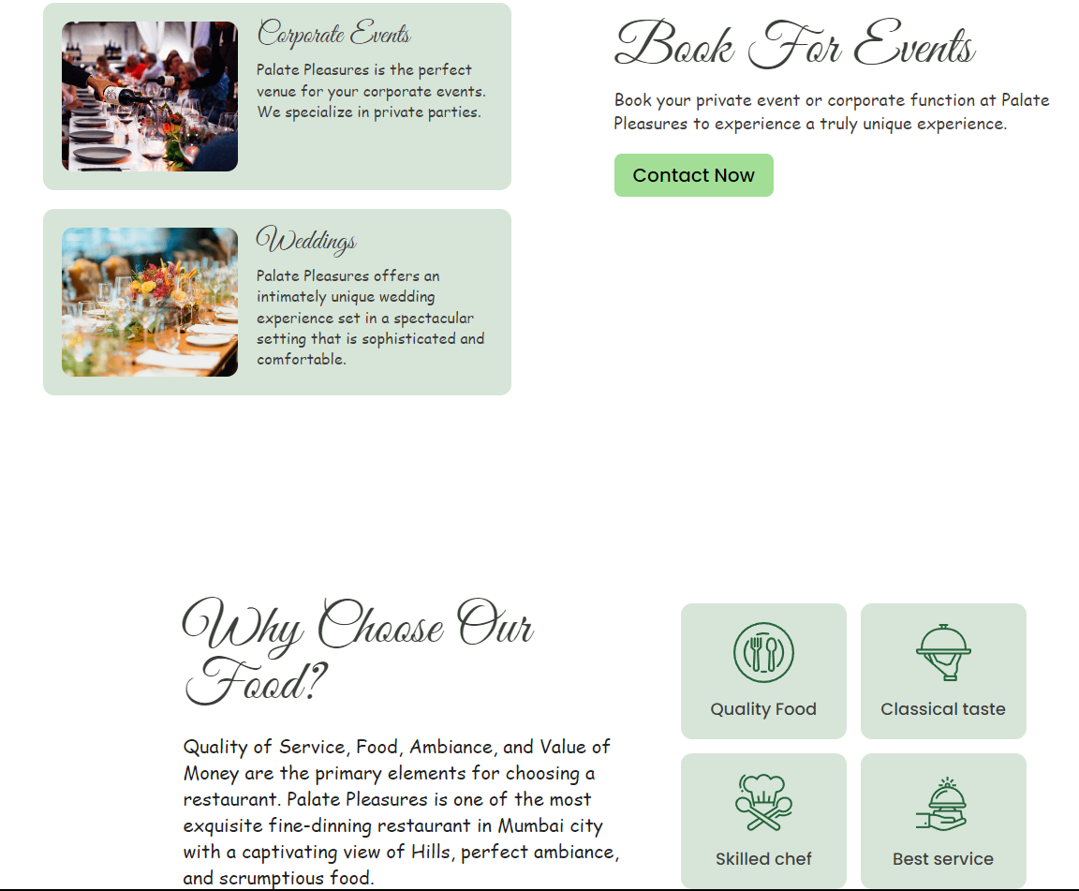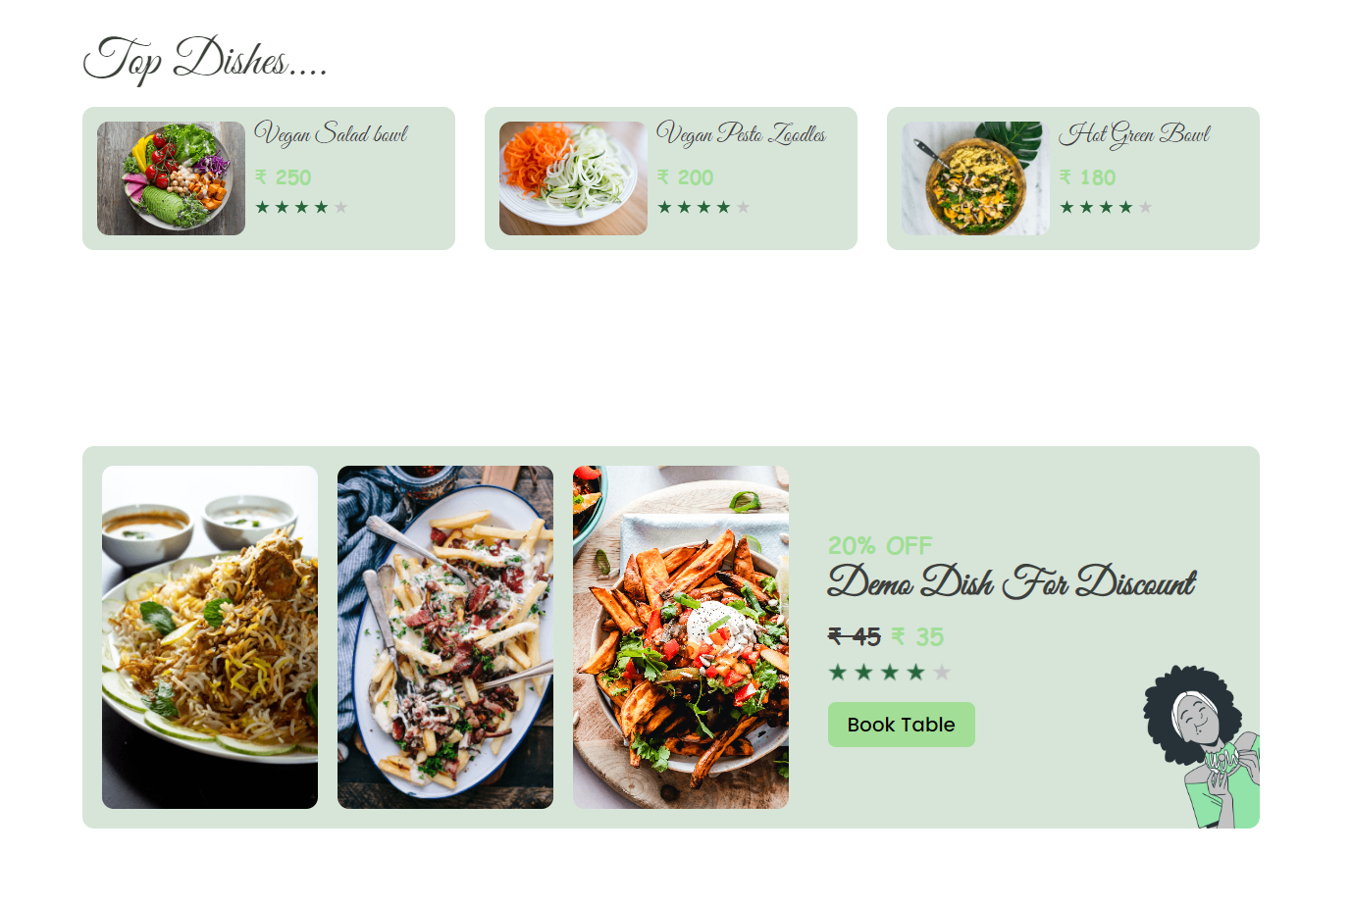

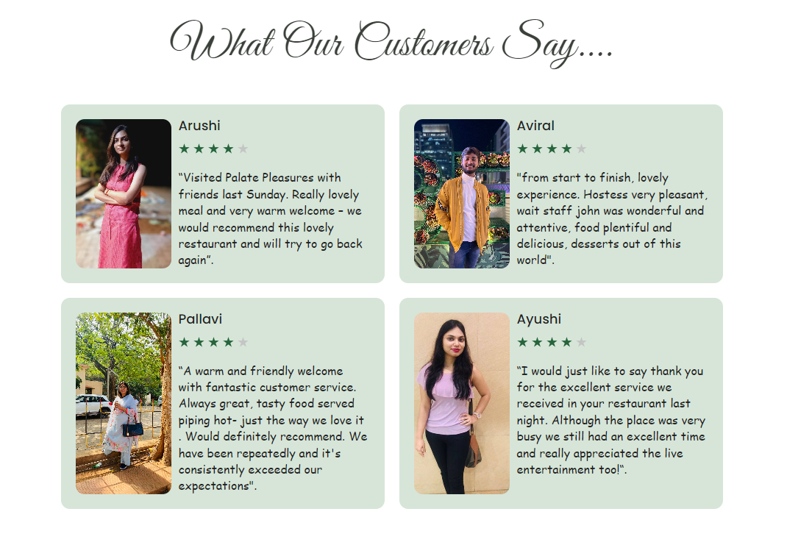

**Source Code:**

**Index.html**

<!DOCTYPE html>

<html lang="en">

<head>

<meta charset="UTF-8">

<meta http-equiv="X-UA-Compatible" content="IE=edge">

<meta name="viewport" content="width=device-width, initial-scale=1.0">

<title>Palate Pleasures</title>

<link rel="stylesheet" href="./reset.css">

<link rel="stylesheet" href="./globalStyles.css">

<link rel="stylesheet" href="./components.css">

<!-- aos library css -->

<link rel="stylesheet" href="https://unpkg.com/aos@next/dist/aos.css" />

<!-- google fonts api-->

<link rel="preconnect" href="https://fonts.gstatic.com">

<link href="https://fonts.googleapis.com/css2?family=Great+Vibes&display=swap" rel="stylesheet">

<!-- Add your custom css -->

<link rel="stylesheet" href="./home.css">

</head>

<body>

<!-- Nav Section -->

<div class="nav">

<div class="container">

<div class="nav__wrapper">

<a href="./index.html" class="logo">

<img src="./images/Logo-1.png" alt="Palate Pleasures">

</a>

<nav>

<div class="nav__icon">

<svg xmlns="http://www.w3.org/2000/svg" width="24" height="24" viewBox="0 0 24 24" fill="none"

stroke="currentColor" stroke-width="2" stroke-linecap="round" stroke-linejoin="round"

class="feather feather-menu">

<line x1="3" y1="12" x2="21" y2="12" />

<line x1="3" y1="6" x2="21" y2="6" />

<line x1="3" y1="18" x2="21" y2="18" />

</svg>

</div>

<div class="nav__bgOverlay"></div>

<ul class="nav__list">

<div class="nav__close">

<svg xmlns="http://www.w3.org/2000/svg" width="24" height="24" viewBox="0 0 24 24" fill="none"

stroke="currentColor" stroke-width="2" stroke-linecap="round" stroke-linejoin="round"

class="feather feather-x">

<line x1="18" y1="6" x2="6" y2="18" />

<line x1="6" y1="6" x2="18" y2="18" />

</svg>

</div>

<div class="nav__list__wrapper">

<li><a class="nav__link" href="./index.html">Home</a></li>

<li><a class="nav__link" href="./menu.html">Menu</a></li>

<li><a class="nav__link" href="./about.html">About</a></li>

<li><a class="nav__link" href="./contact.html">Contact</a></li>

<li><a class="btn primary-btn" href="./booking.html">Book Table</a></li>

</div>

</ul>

</nav>

</div>

</div>

</div>

<!-- End Nav Section -->

<!-- Hero Section -->

<section id="hero">

<div class="container">

<div class="hero__wrapper">

<div class="hero__left" data-aos="fade-left">

<div class="hero__left__wrapper">

<h1 class="hero__heading">The Flavour of Tradition</h1>

<p class="hero__info">

We are a multi-cuisine restaurant offering a wide variety of food experience in both casual and fine

dining

environment.

</p>

<div class="button__wrapper">

<a href="./menu.html" class="btn primary-btn">Explore Menu</a>

<a href="./booking.html" class="btn">Book Table</a>

</div>

</div>

</div>

<div class="hero__right" data-aos="fade-right">

<div class="hero__imgWrapper">

<img src="./images/heroImg.png">

</div>

</div>

</div>

</div>

</section>

<!-- End Hero Section -->

<!-- Store Info Section -->

<section id="storeInfo" data-aos="fade-up">

<div class="container">

<div class="storeInfo__wrapper">

<div class="storeInfo__item">

<div class="storeInfo__icon">

<img src="./images/wall-clock-icon.svg" alt="clock icon">

</div>

<h3 class="storeInfo__title">

8 AM - 11 PM

</h3>

<p class="storeInfo__text">

Opening Hour

</p>

</div>

<div class="storeInfo__item">

<div class="storeInfo__icon">

<img src="./images/address-icon.svg" alt="clock icon">

</div>

<h3 class="storeInfo__title">

Raheja Towers, Bandra Kurla Complex, Bandra East, Mumbai- 400051.

</h3>

<p class="storeInfo__text">

Address

</p>

</div>

<div class="storeInfo__item">

<div class="storeInfo__icon">

<img src="./images/phone-icon.svg" alt="clock icon">

</div>

<h3 class="storeInfo__title">

+918953078164

</h3>

<p class="storeInfo__text">

Call Now

</p>

</div>

</div>

</div>

</section>

<!-- End Store Info Section -->

<!-- Our Specials Section -->

<section id="ourSpecials" data-aos="fade-up">

<div class="container">

<div class="ourSpecials__wrapper">

<div class="ourSpecials__left">

<div class="ourSpecials__item">

<div class="ourSpecials__item__img">

<img src="./images/food-3.png" alt="food img">

</div>

<h2 class="ourSpecials__item__title">

Sweet Potato Fries Bowl

</h2>

<p class="ourSpecials__item__price">

&#8377 150

<p>

<div class="ourSpecials__item__stars">

<img src="./images/3star.png" alt="3 stars">

</div>

<p class="ourSpecials__item__text">

These Sweet Potato Fries bowl are a glorious, messy plate of goodness. Crispy sweet potato fries loaded

with lots of fresh summer vegetables and a lime ranch. By adding a seasoning blend with chipotle powder,

garlic, and onion, these spicy sweet potato fries are full of flavor.

</p>

</div>

<div class="ourSpecials__item">

<div class="ourSpecials__item__img">

<img src="./images/food-1.png" alt="food img">

</div>

<h2 class="ourSpecials__item__title">

Vegan Salad bowl

</h2>

<p class="ourSpecials__item__price">

&#8377 250

</p>

<div class="ourSpecials__item__stars">

<img src="./images/3star.png" alt="3 stars">

</div>

<p class="ourSpecials__item__text">

Vegan salad bowl are immensely satisfying with any combination of whole grains, pulses, noodles, raw or

cooked fruits, and veggies all topped off with a delicious sauce or dressing – each bite is an explosion

of flavors and textures.

</p>

</div>

</div>

<div class="ourSpecials__right">

<h2 class="ourSpecials__title">

Our Specials

</h2>

<p class="ourSpecials__text">

All of our food is prepared daily at our restaurants to ensure the highest quality, freshest meals are

delivered to our customers

</p>

<a href="./booking.html" class="btn primary-btn">Book Table</a>

</div>

</div>

</div>

</section>

<!-- End Our Specials Section -->

<!-- Top Dishes -->

<section id="dishGrid" data-aos="fade-up">

<div class="container">

<h2 class="dishGrid__title">

Top Dishes....

</h2>

<div class="dishGrid__wrapper">

<div class="dishGrid__item">

<div class="dishGrid__item__img">

<img src="./images/food-1.png" alt="food img">

</div>

<div class="dishGrid__item__info">

<h3 class="dishGrid__item__title">

Vegan Salad bowl

</h3>

<p class="dishGrid__item__price">&#8377 250</p>

<div class="dishGrid__item__stars">

<img src="./images/3star.png" alt="3 star">

</div>

</div>

</div>

<div class="dishGrid__item">

<div class="dishGrid__item__img">

<img src="./images/food-2.png" alt="food img">

</div>

<div class="dishGrid__item__info">

<h3 class="dishGrid__item__title">

Vegan Pesto Zoodles

</h3>

<p class="dishGrid__item__price">&#8377 200</p>

<div class="dishGrid__item__stars">

<img src="./images/3star.png" alt="3 star">

</div>

</div>

</div>

<div class="dishGrid__item">

<div class="dishGrid__item__img">

<img src="./images/food-7.png" alt="food img">

</div>

<div class="dishGrid__item__info">

<h3 class="dishGrid__item__title">

Hot Green Bowl

</h3>

<p class="dishGrid__item__price">&#8377 180</p>

<div class="dishGrid__item__stars">

<img src="./images/3star.png" alt="3 star">

</div>

</div>

</div>

</div>

</div>

</section>

<!-- End Top Dishes -->

<!-- Discount Section -->

<section id="discount" data-aos="fade-up">

<div class="container">

<div class="discount__wrapper">

<div class="discount__images">

<div class="discount__img1">

<img src="./images/food-5.png" alt="Food img">

</div>

<div class="discount__img2">

<img src="./images/food-4.png" alt="Food img">

</div>

<div class="discount__img3">

<img src="./images/food-3.png" alt="Food img">

</div>

</div>

<div class="discount__info">

<p class="discount__text">20% OFF</p>

<h3 class="discount__title">Demo Dish For Discount</h3>

<p class="discount__price">

<span class="discount__oldPrice">&#8377 45</span>

<span class="discount__newPrice">&#8377 35</span>

</p>

<div class="discount__stars">

<img src="./images/3star.png" alt="3 stars">

</div>

<a class="btn primary-btn" href="./booking.html">Book Table</a>

</div>

</div>

</div>

</section>

<!-- End Discount Section -->

<!-- Events Media -->

<section id="eventsMedia" data-aos="fade-up">

<div class="container">

<div class="eventsMedia__wrapper">

<div class="eventsMedia__1">

<img src="./images/eventsMedia1.png" alt="events">

<a href="#" class="eventsMedia__1__playButton">

<img src="./images/playIcon.svg" alt="play button">

</a>

</div>

<div class="eventMedia__2">

<img src="./images/eventsMedia2.png" alt="events">

</div>

</div>

</div>

</section>

<!-- End Events Media -->

<!-- Events Info -->

<section id="eventsInfo" data-aos="fade-up">

<div class="container">

<div class="eventsInfo__wrapper">

<div class="eventsInfo__left">

<div class="eventsInfo__item">

<div class="eventsInfo__item__img">

<img src="./images/event-corporate.png" alt="corporate events">

</div>

<div class="eventsInfo__item__info">

<h2 class="eventsInfo__item__title">Corporate Events</h2>

<p class="eventsInfo__item__text">

Palate Pleasures is the perfect venue for your corporate events. We specialize in private parties.

</p>

</div>

</div>

<div class="eventsInfo__item">

<div class="eventsInfo__item__img">

<img src="./images/event-weedings.png" alt="wedding events">

</div>

<div class="eventsInfo__item__info">

<h2 class="eventsInfo__item__title">Weddings</h2>

<p class="eventsInfo__item__text">

Palate Pleasures offers an intimately unique wedding experience set in a spectacular setting that is

sophisticated and comfortable.

</p>

</div>

</div>

</div>

<div class="eventsInfo__right">

<h2 class="eventsInfo__title">Book For Events</h2>

<p class="eventsInfo__text">Book your private event or corporate function at Palate Pleasures to experience a

truly unique experience.</p>

<a href="./contact.html" class="btn primary-btn">Contact Now</a>

</div>

</div>

</div>

</section>

<!-- End Events Info -->

<!-- Why Us section -->

<section id="whyUs">

<div class="container">

<div class="whyUs__wrapper">

<div class="whyUs__left" data-aos="fade-right">

<h3 class="whyUs__title">

Why Choose Our Food?

</h3>

<p class="whyUs__text">

Quality of Service, Food, Ambiance, and Value of Money are the primary elements for choosing a restaurant.

Palate Pleasures is one of the most exquisite fine-dinning restaurant in Mumbai city with a captivating

view of Hills, perfect ambiance, and scrumptious food.

</p>

</div>

<div class="whyUs__right" data-aos="fade-left">

<div class="whyUs__items__wrapper">

<div class="whyUs__item">

<div class="whyUs__item__icon">

<img src="./images/whyUs-icon1.svg" alt="quality Food">

</div>

<p class="whyUs__item__text">Quality Food</p>

</div>

<div class="whyUs__item">

<div class="whyUs__item__icon">

<img src="./images/whyUs-icon2.svg" alt="Classical taste">

</div>

<p class="whyUs__item__text">Classical taste</p>

</div>

<div class="whyUs__item">

<div class="whyUs__item__icon">

<img src="./images/whyUs-icon3.svg" alt="Skilled chef">

</div>

<p class="whyUs__item__text">Skilled chef</p>

</div>

<div class="whyUs__item">

<div class="whyUs__item__icon">

<img src="./images/whyUs-icon4.svg" alt="Best service">

</div>

<p class="whyUs__item__text">Best service</p>

</div>

</div>

</div>

</div>

</div>

</section>

<!-- End Why Us section -->

<!-- Testimonial Section -->

<section id="testimonial">

<div class="container">

<div class="testimonial__wrapper" data-aos="fade-up">

<h2 class="testimonial__title">What Our Customers Say....</h2>

<div class="testimonial__items__wrapper">

<div class="testimonial__item">

<div class="testimonial__item__img">

<img src="./images/Screenshot_2021-10-05-12-59-32-717_com.google.android.apps.photos~2.jpg" alt="Arushi">

</div>

<div class="testimonial__item__info">

<h3 class="testimonial__item__name">Arushi</h3>

<div class="testimonial__item__stars">

<img src="./images/3star.png" alt="3 star">

</div>

<p class="testimonial__item__text">

“Visited Palate Pleasures with friends last Sunday. Really lovely meal and very warm welcome – we would

recommend this lovely restaurant and will try to go back again”.

</p>

</div>

</div>

<div class="testimonial__item">

<div class="testimonial__item__img">

<img src="./images/IMG-20221211-WA0008.jpg" alt="Aviral">

</div>

<div class="testimonial__item__info">

<h3 class="testimonial__item__name">Aviral</h3>

<div class="testimonial__item__stars">

<img src="./images/3star.png" alt="3 star">

</div>

<p class="testimonial__item__text">

"from start to finish, lovely experience. Hostess very pleasant, wait staff john was wonderful and

attentive, food plentiful and delicious, desserts out of this world".

</p>

</div>

</div>

<div class="testimonial__item">

<div class="testimonial__item__img">

<img src="./images/IMG-20230121-WA0005.jpg" alt="Pallavi">

</div>

<div class="testimonial__item__info">

<h3 class="testimonial__item__name">Pallavi</h3>

<div class="testimonial__item__stars">

<img src="./images/3star.png" alt="3 star">

</div>

<p class="testimonial__item__text">

“A warm and friendly welcome with fantastic customer service. Always great, tasty food served piping

hot- just the way we love it . Would definitely recommend. We have been repeatedly and it's consistently

exceeded our expectations".

</p>

</div>

</div>

<div class="testimonial__item">

<div class="testimonial__item__img">

<img src="./images/IMG-20220526-WA0010.jpg" alt="Ayushi">

</div>

<div class="testimonial__item__info">

<h3 class="testimonial__item__name">Ayushi</h3>

<div class="testimonial__item__stars">

<img src="./images/3star.png" alt="3 star">

</div>

<p class="testimonial__item__text">

“I would just like to say thank you for the excellent service we received in your restaurant last night.

Although the place was very busy we still had an excellent time and really appreciated the live

entertainment too!“.

</p>

</div>

</div>

</div>

</div>

</div>

</section>

<!-- End Testimonial Section -->

<!-- Newsletter Section -->

<section id="newsletter" data-aos="fade-up">

<div class="container">

<div class="newsletter__wrapper">

<div class="newsletter__info">

<h3 class="newsletter__title">Join Newsletter</h3>

<p class="newsletter__text">

Get notified with the latest news and recent offers from the “Palate Pleasures”.

</p>

</div>

<div class="newsletter__form">

<form action="">

<label for="email">

<input type="email" placeholder="Your Email Address">

</label>

<button type="submit">Join</button>

</form>

</div>

</div>

</div>

</section>

<!-- End Newsletter Section -->

<!-- Footer -->

<footer>

<div class="container">

<div class="footer__wrapper">

<div class="footer__col1">

<div class="footer__logo">

<img src="./images/Luxury Minimalist Elegant Sushi Restaurant Typography Logo.png" alt="Palate Pleasures">

</div>

<p class="footer__desc">

Fresh and delicious traditional Indian food to delight the whole family.

</p>

<div class="footer__socials">

<h4 class="footer__socials__title">Follow us on:</h4>

<ol class="footer__socials__list">

<li>

<a href="#">

<svg xmlns="http://www.w3.org/2000/svg" width="24" height="24" viewBox="0 0 24 24" fill="none"

stroke="black" stroke-width="2" stroke-linecap="round" stroke-linejoin="round"

class="feather feather-facebook">

<path d="M18 2h-3a5 5 0 0 0-5 5v3H7v4h3v8h4v-8h3l1-4h-4V7a1 1 0 0 1 1-1h3z" />

</svg>

</a>

</li>

<li>

<a href="#">

<svg xmlns="http://www.w3.org/2000/svg" width="24" height="24" viewBox="0 0 24 24" fill="none"

stroke="black" stroke-width="2" stroke-linecap="round" stroke-linejoin="round"

class="feather feather-instagram">

<rect x="2" y="2" width="20" height="20" rx="5" ry="5" />

<path d="M16 11.37A4 4 0 1 1 12.63 8 4 4 0 0 1 16 11.37z" />

</svg>

</a>

</li>

<li>

<a href="#">

<svg xmlns="http://www.w3.org/2000/svg" width="24" height="24" viewBox="0 0 24 24" fill="none"

stroke="black" stroke-width="2" stroke-linecap="round" stroke-linejoin="round"

class="feather feather-twitter">

<path

d="M23 3a10.9 10.9 0 0 1-3.14 1.53 4.48 4.48 0 0 0-7.86 3v1A10.66 10.66 0 0 1 3 4s-4 9 5 13a11.64 11.64 0 0 1-7 2c9 5 20 0 20-11.5a4.5 4.5 0 0 0-.08-.83A7.72 7.72 0 0 0 23 3z" />

</svg>

</a>

</li>

</ol>

</div>

</div>

<div class="footer__col2">

<h3 class="footer__text__title">

Links

</h3>

<ol class="footer__text">

<li>

<a href="/index.html">Home</a>

</li>

<li>

<a href="./menu.html">Menu</a>

</li>

<li>

<a href="./booking.html">Book Table</a>

</li>

<li>

<a href="./about.html">About Us</a>

</li>

<li>

<a href="./contact.html">contact Us</a>

</li>

<li>

<a href="#">Privacy Policy</a>

</li>

</ol>

</div>

<div class="footer__col3">

<h3 class="footer__text__title">

Support

</h3>

<ol class="footer__text">

<li>

<a href="#">Contact</a>

</li>

<li>

<a href="#">Support Center</a>

</li>

<li>

<a href="#">Feedback</a>

</li>

</ol>

</div>

<div class="footer__col4">

<h3 class="footer__text__title">

Contact

</h3>

<ol class="footer__text">

<li>

<a href="#">+918953078164, +919219055466</a>

</li>

<li>

<a href="#">PalatePleasures@gmail.com</a>

</li>

<li>

<a href="#">1st Floor, Block G, Raheja Towers, Bandra Kurla Complex, Bandra East, Mumbai- 400051. </a>

</li>

</ol>

</div>

</div>

</div>

</footer>

<div id="copyright">

<div class="container">

<p class="copyright__text">

© copyright 2023 Palate Pleasures | All rights reserved

</p>

</div>

</div>

<!-- End Footer -->

<!-- aos script -->

<script src="https://unpkg.com/aos@next/dist/aos.js"></script>

<!-- custom script -->

<script src="./main.js"></script>

</body>

</html>

**Home.CSS**

/* hero section styles */

.hero__wrapper {

display: flex;

align-items: center;

justify-content: center;

flex-direction: column-reverse;

gap: 5rem;

}

.hero__left__wrapper {

max-width: 350px;

}

.hero__imgWrapper {

max-width: 400px;

width: 80%;

margin: 0 auto;

}

.hero__heading {

font-family: 'Great Vibes';

line-height: 1em;

text-align: center;

margin-bottom: 1.5rem;

color: var(--black-1);

}

.hero__info {

text-align: center;

color: var(--black-2);

}

.button__wrapper {

text-align: center;

}

@media only screen and (min-width: 768px) {

.hero__wrapper {

flex-direction: row;

gap: 0;

}

.hero__left {

flex: 3;

}

.hero__right {

flex: 4;

}

.hero__heading {

font-size: 6rem;

margin-bottom: 2rem;

text-align: left;

}

.hero__info {

margin-bottom: 2rem;

text-align: left;

font-size: 2rem;

}

.button__wrapper {

text-align: left;

}

.hero__imgWrapper {

max-width: none;

width: 90%;

}

}

@media only screen and (max-width: 900px) {

.hero__left,

.hero__right {

flex: 1;

}

}

/* Our Specials Section Styles */

#ourSpecials {

padding-top: 10rem;

}

.ourSpecials__wrapper {

display: flex;

flex-direction: column;

gap: 3rem;

}

.ourSpecials__left {

display: flex;

gap: 1rem;

}

.ourSpecials__item {

background-color: var(--LightGreen-1);

padding: 1.2rem;

padding-top: 5rem;

border-radius: 12px;

width: 45%;

margin: 0 auto;

}

.ourSpecials__item__img {

margin-top: calc(-50% - 2rem);

margin-bottom: 2rem;

border-radius: 12px;

height: 150px;

overflow: hidden;

}

.ourSpecials__item__img img {

object-fit: cover;

}

.ourSpecials__item__title {

font-size: 1.4rem;

color: var(--black-1);

font-weight: 600;

margin-bottom: 1rem;

}

.ourSpecials__item__price {

color: var(--green-1);

font-weight: 600;

margin-bottom: 1rem;

}

.ourSpecials__item__stars {

height: 1.5rem;

width: max-content;

margin-bottom: 1rem;

}

.ourSpecials__item__text {

color: var(--black-2);

}

.ourSpecials__title {

color: var(--black-1);

}

.ourSpecials__text {

font-size: 2rem;

color: var(--black-2);

margin-bottom: 1rem;

}

@media only screen and (min-width: 768px) {

#ourSpecials {

padding-top: 15rem;

}

#ourSpecials .container {

max-width: 900px;

}

.ourSpecials__wrapper {

flex-direction: row;

}

.ourSpecials__right {

flex: 2;

}

.ourSpecials__left {

flex: 4;

gap: 2rem;

}

.ourSpecials__item {

padding: 2rem;

}

.ourSpecials__item__title {

font-size: 2.4rem;

line-height: 1.4em;

margin-bottom: 1.5rem;

}

.ourSpecials__item__price {

font-size: 1.8rem;

margin-bottom: 1rem;

}

.ourSpecials__item__stars {

margin-bottom: 2rem;

}

.ourSpecials__item__text {

font-size: 1.6rem;

}

.ourSpecials__title {

font-size: 6rem;

margin-bottom: 1.5rem;

}

.ourSpecials__text {

font-size: 1.8rem;

margin-bottom: 1.5rem;

}

}

@media only screen and (max-width: 300px) {

.ourSpecials__left {

flex-wrap: wrap;

gap: 10rem;

}

.ourSpecials__item {

width: 100%;

}

}

/* End Our Specials Section Styles */

/* Top Dishes Styles */

.dishGrid__title{

font-weight: 450;

}

@media only screen and (min-width: 768px) {

.dishGrid__title{

font-size: 5rem;

}

}

/* End Dishes Styles */

/* Discount Styles */

.discount__wrapper {

display: flex;

flex-direction: column;

padding: 1.5rem;

border-radius: 12px;

background: var(--lightGreen-1) url(./images/discount-illustration.png)

no-repeat bottom right / 100px;

}

.discount__images {

display: flex;

gap: 1rem;

width: 100%;

margin-bottom: 2rem;

}

.discount__img1 {

flex: 2;

}

.discount__img2 {

flex: 3;

}

.discount__images img {

object-fit: cover;

border-radius: 12px;

}

.discount__text {

font-size: 1.4rem;

font-weight: 900;

color: var(--green-1);

margin-bottom: 0.5rem;

}

.discount__title {

color: var(--black-1);

font-weight: 600;

margin-bottom: 1rem;

}

.discount__price {

font-weight: 600;

display: flex;

gap: 1rem;

margin-bottom: 1rem;

}

.discount__oldPrice {

color: var(--black-2);

text-decoration: line-through;

}

.discount__newPrice {

color: var(--green-1);

}

.discount__stars {

width: max-content;

height: 15px;

margin-bottom: 1rem;

}

@media only screen and (min-width: 768px) {

.discount__wrapper {

flex-direction: row;

gap: 4rem;

padding: 2rem;

align-items: center;

background-size: 150px;

margin: 0 auto;

}

.discount__images {

flex: 5;

margin-bottom: 0;

gap: 2rem;

}

.discount__img1,

.discount__img2,

.discount__img3 {

flex: 1;

height: 350px;

}

.discount__info {

flex: 3;

}

.discount__text {

font-size: 2.4rem;

}

.discount__title {

font-size: 4rem;

margin-bottom: 1.5rem;

}

.discount__price {

font-size: 2.4rem;

}

.discount__stars {

height: 20px;

margin-bottom: 2rem;

}

}

@media only screen and (max-width: 1000px) {

.discount__wrapper {

gap: 2rem;

}

.discount__img3 {

display: none;

}

}

/* End Discount Styles */

/* EventsMedia Styles */

.eventsMedia__wrapper {

display: flex;

gap: 1rem;

}

.eventsMedia__1 {

position: relative;

}

.eventsMedia__1__playButton {

display: inline-block;

position: absolute;

left: 50%;

top: 50%;

transform: translate(-50%, -50%);

max-width: 50px;

}

@media only screen and (min-width: 768px) {

.eventsMedia__wrapper {

gap: 2rem;

}

.eventsMedia__1__playButton {

max-width: 100px;

}

}

/* End EventsMedia Styles */

/* EventsInfo Styles*/

#eventsInfo {

padding-top: 0;

}

.eventsInfo__wrapper {

display: flex;

flex-direction: column;

}

.eventsInfo__item {

display: flex;

gap: 1rem;

padding: 1rem;

background: var(--lightGreen-1);

margin-bottom: 1.5rem;

border-radius: 12px;

}

.eventsInfo__item__img {

border-radius: 12px;

overflow: hidden;

flex: 3;

}

.eventsInfo__item__info {

flex: 4;

}

.eventsInfo__item__img img {

object-fit: cover;

}

.eventsInfo__item__title {

margin-bottom: 1rem;

color: var(--black-1);

}

.eventsInfo__item__text {

font-size: 3rem;

color: var(--black-2);

}

.eventsInfo__right {

margin-top: 2rem;

}

.eventsInfo__title {

color: var(--black-1);

margin-bottom: 1rem;

}

.eventsInfo__text {

color: var(--black-2);

font-size: 1.4rem;

margin-bottom: 1rem;

}

@media only screen and (min-width: 760px) {

.eventsInfo__wrapper {

flex-direction: row;

gap: 2rem;

}

.eventsInfo__left,

.eventsInfo__right {

flex: 1;

}

.eventsInfo__item {

padding: 2rem;

gap: 2rem;

max-width: 500px;

margin-bottom: 2rem;

}

.eventsInfo__item__title {

font-size: 3rem;

}

.eventsInfo__item__text {

font-size: 1.6rem;

}

.eventsInfo__title {

font-size: 6rem;

}

.eventsInfo__text {

max-width: 500px;

font-size: 1.8rem;

margin-bottom: 2rem;

}

}

/* End EventsInfo Styles*/

/* WhyUs Section */

.whyUs__wrapper {

display: flex;

align-items: center;

justify-content: center;

flex-direction: column;

gap: 4rem;

}

.whyUs__left {

text-align: center;

}

.whyUs__title {

color: var(--black-1);

margin-bottom: 1rem;

}

.whyUs__right {

text-align: center;

}

.whyUs__items__wrapper {

display: grid;

grid-template-columns: 1fr 1fr;

gap: 1rem;

}

.whyUs__item {

background: var(--lightGreen-1);

padding: 2rem;

border-radius: 12px;

}

.whyUs__item__icon {

max-width: 56px;

margin: 0 auto;

margin-bottom: 1rem;

}

.whyUs__item__text {

font-family: Poppins;

font-size: 1.4rem;

font-weight: 500;

color: var(--black-1);

}

@media only screen and (min-width: 768px) {

.whyUs__wrapper {

flex-direction: row;

max-width: 900px;

margin: 0 auto;

}

.whyUs__left {

flex: 4;

text-align: left;

}

.whyUs__right {

flex: 3;

}

.whyUs__title {

font-size: 6rem;

margin-bottom: 2rem;

}

.whyUs__text {

font-size: 2rem;

line-height: 1.4em;

}

.whyUs__items__wrapper {

gap: 1.5rem;

}

.whyUs__item {

padding: 2rem;

}

.whyUs__item__icon {

max-width: 65px;

margin-bottom: 1.5rem;

}

.whyUs__item__text {

font-size: 1.8rem;

}

}

/* End WhyUs Section */

/* Testimonial Section */

.testimonial__wrapper {

max-width: 400px;

margin: 0 auto;

}

.testimonial__title {

font-size: 1.8rem;

margin-bottom: 3rem;

text-align: center;

color: var(--black-1);

}

.testimonial__items__wrapper {

display: grid;

grid-template-columns: 1fr;

gap: 1rem;

}

.testimonial__item {

padding: 1rem;

display: flex;

gap: 1rem;

background-color: var(--lightGreen-1);

border-radius: 12px;

}

.testimonial__item__info {

flex: 4;

}

.testimonial__item__img {

flex: 2;

border-radius: 12px;

overflow: hidden;

width: 100%;

height: 100%;

}

.testimonial__item__img img {

object-fit: cover;

}

.testimonial__item__name {

font-size: 1.4rem;

font-family: poppins;

margin-bottom: 1rem;

}

.testimonial__item__stars {

max-height: 15px;

width: max-content;

margin-bottom: 1.5rem;

}

.testimonial__item__text {

font-size: 1.4rem;

}

@media only screen and (min-width: 768px) {

.testimonial__wrapper {

max-width: 900px;

}

.testimonial__title {

font-size: 6rem;

margin-bottom: 5rem;

}

.testimonial__items__wrapper {

grid-template-columns: 1fr 1fr;

gap: 2rem;

}

.testimonial__item {

padding: 2rem;

}

.testimonial__item__name {

font-size: 1.8rem;

margin-bottom: 1.5rem;

}

.testimonial__item__stars {

margin-bottom: 2rem;

}

.testimonial__item__text {

font-size: 1.6rem;

line-height: 1.4em;

}

}

@media only screen and (max-width: 350px) {

.testimonial__item {

flex-direction: column;

}

.testimonial__item__img,

.testimonial__item__info {

flex: auto;

}

}

/* End Testimonial Section */

/* Newsletter Section */

.newsletter__wrapper {

display: flex;

flex-direction: column;

background-color: var(--green-2);

padding: 1.5rem;

border-radius: 8px;

gap: 2rem;

}

.newsletter__title {

font-size: 1.8rem;

color: var(--black-1);

font-weight: 600;

margin-bottom: 1.3rem;

}

.newsletter__text {

font-size: 1.4rem;

color: var(--black-2);

font-weight: 500;

}

.newsletter__form form {

position: relative;

width: 100%;

border-radius: 8px;

overflow: hidden;

}

.newsletter__form label {

width: 100%;

}

.newsletter__form input {

width: 100%;

font-size: 1.4rem;

padding: 1.5rem 1rem;

border: none;

}

.newsletter__form input::placeholder {

color: rgb(168, 166, 166);

}

.newsletter__form button[type='submit'] {

color: var(--black-1);

border: none;

font-size: 1.4rem;

padding: 0 2rem;

height: 100%;

/* width: 100%; */

position: absolute;

right: 0;

top: 0;

}

@media only screen and (min-width: 768px) {

.newsletter__wrapper {

flex-direction: row;

padding: 5rem;

align-items: center;

}

.newsletter__info,

.newsletter__form {

flex: 1;

}

.newsletter__title {

font-size: 3.6rem;

margin-bottom: 2rem;

}

.newsletter__text {

font-size: 1.8rem;

max-width: 400px;

}

.newsletter__form {

max-width: 450px;

border-radius: 12px;

}

.newsletter__form input {

font-size: 1.8rem;

padding: 2rem;

}

.newsletter__form button[type='submit'] {

font-size: 1.8rem;

padding: 0 3rem;

}

}

/* End Newsletter Section */